APPENDIX A - REWARDS & POSITIVE DISCIPLINE POLICY

REWARDS and POSITIVE DISCIPLINE
At School X we aim to operate a positive approach rewarding students and celebrating achievement. Rewards are given for recognition of good behaviour, attendance, achievement , effort, willingness to help and appearance. Rewards can be given both in the classroom setting by teachers and also in a more summative form by Subject Leaders, Learning Managers and Senior Leaders.

In the classroom these will take the form of praise, credits in planners and retaining behaviour stars and uniform credits.

From Subject Leaders, Learning Managers and Senior Leaders rewards may take the form of letters or postcards of commendation being sent home, recognition in assemblies and/or certificates. Both Subject Leaders and Learning Managers are encouraged to be creative in ways to rewards individuals with intangible rewards which help build an environment where achievement is celebrated by all. In addition both Subject Leaders and Learning Managers are encouraged to recommend when they feel a letter of commendation from the Headteacher may be appropriate.

Behaviour Stars
In addition to the rewards mentioned above students collect stickers for behaviour stars. These accumulate and lead to an end of year trip for those students who are successful . Learning managers will organise the end of year trip for their year group.

Behaviour stars are monitored by form tutors and communicated to Learning Managers who may arrange additional rewards for individuals at some points during the year.

Credits
Credits can be given via a stamp in the planner by any member of staff for good work, homework, verbal answers, willingness to help, improvement and many other reasons. Credits lead to tangible rewards for students and students are welcome to ‘cash-in’ their credits for rewards at the ‘Fairtrade and Rewards shop’ on Wednesday lunchtimes between 12.40 and 1pm. (This will begin partway through the academic year to allow students time to accrue credits, specific dates will be set).
The value of credits and rewards available are shown below.
 | Years 7-10 | Year 11
50 Credits | School X USB Memory Stick
100 Credits | £5 Voucher | £5 voucher OR £5 off Prom Ticket
150 Credits | £10 Voucher | £10 voucher OR £10 off Prom ticket
200 Credits | £15 voucher | £15 voucher OR £15 off Prom ticket

Once credits are cashed in students must start collecting again.
Learning Manager Rewards
In addition to the rewards above, Learning Managers are encouraged to be creative in ways to reward students. Prizes of some sort could be given for best behaved form, best attendees and form with the most credits.

SANCTIONS
Whilst we encourage a positive approach, there are times when students fail to meet the required standards and in order to improve behaviour and attitude we have a system of sanctions. The procedure on the diagram page opposite shows the course of action that must be taken by staff.
Standard DTs
These are detentions that follow the normal path of inappropriate behaviour or problems in the classroom. The standard DTs follow increasing levels of seriousness for students:

DT1 | Subject Teacher | In school time | between 5 and 30 mins | classroom
DT2 | Subject Leaders | After school (Mon) | 30 minutes | A10/A12
DT3 | Learning Manager | After school (Wed) | 45 minutes | A10/A12
DT4 | Senior Leaders | After school (Fri) | 45 minutes | Hall

In addition, students who do not attend arranged DTs will find that they move to the next level. At DT1 students should be given 2 chances to attend a DT1, where this is not fulfilled the teacher will refer to the Subject Leader and be put into DT2. At DT2 and DT3 an attendance list will be taken and non-attendees will be referred to the next level. At DT4 nonattendees will be followed up by senior leaders and may face isolation.

At DT2, DT3, DT4 it may be normal and appropriate for Subject Leaders, Learning Managers and/or Senior Leaders to telephone and speak to parents. At levels beyond DT1 standard monotonous work will be provided for students.

For standard DTs the appropriate form must be completed and distributed appropriately.
(Detention Advice Form shown on next page).

Green Form – Student/Parent Pink Form – Reception Yellow Form – Teacher Retain
In addition students who accrue 3 DTs at any given level in one half term will also be put into a DT of the next level. For example, a student accruing 3 DT1s in one half term will also be automatically put into a DT2.

Leadership DTs (see sheet opposite)
These will take place at the same time as DT4s and will be staffed by Senior Leaders. In addition to the DT4s students may be placed in this DT for any 3 of the following incidents in any one half term:
- Inappropriate uniform
- Red Card Incidents
- Sent out of class (when students are sent out for acting inappropriately)
(reminder to staff that students sent out of class should be left unattended for max. 5 mins only for time out)

Late DTs
Where there are any 3 lates in one week or where Form Tutors in consultation with Learning Managers feel a late DT is appropriate, a DT3 form will be completed by the learning manager and students attend DT3. In addition, form tutors should monitor lates through the attendance and punctuality record and enter students into a DT1 where there are 3 lates in one half term.

APPENDIX B – ENTERPRISE ETHOS

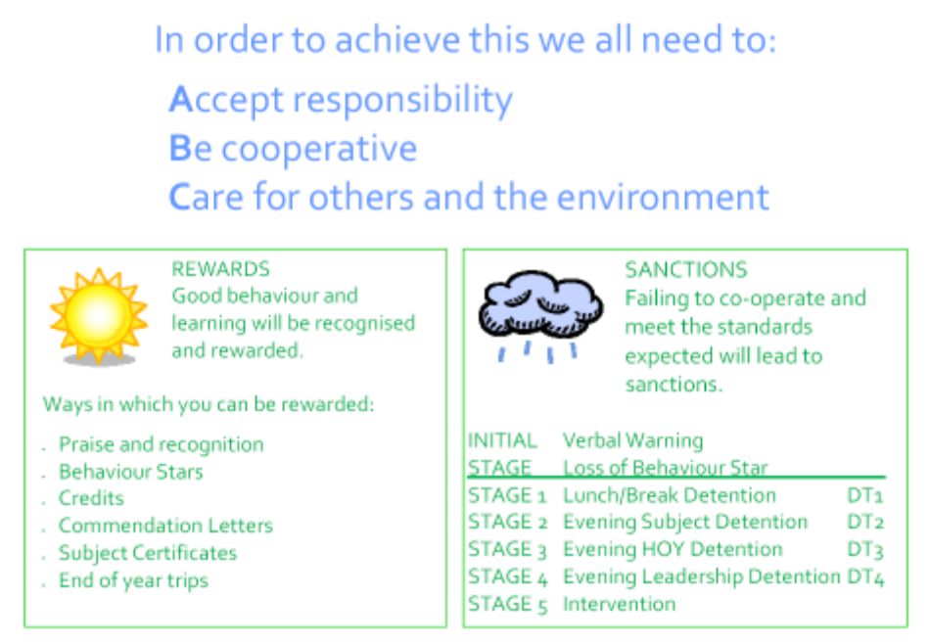

The poster opposite is displayed in all classrooms and sets out our vision for the enterprising ethos of the school.

The sunrise image shows the ‘Enterprise Skills’ which were identified in our application for specialism and have been used since as the basis for enterprise activities. We believe the ‘Enterprise Skills’ to be transferrable skills that, if well
developed and utilised, lead to successful and enterprising futures.

The ‘Enterprise Skills’ are the first eight skills shown on the sunrise:
- PLANNING
- TEAMWORK
- PROBLEM SOLVING
- COMMUNICATION
- DECISION MAKING
- PRESENTATION
- EVALUATION
- CREATIVITY (this has been added to the original skills)

The following five words are the SEAL (SOCIAL and EMOTIONAL ASPECTS of LEARNING) attributes. These are:
- MANAGING FEELINGS
- SELF AWARENESS
- SOCIAL SKILLS
- MOTIVATION
- EMPATHY
These attributes follow on from the ‘Enterprise Skills’ as important aspects which make up the whole person and contribute to the success of an individual.
The statement below the sunrise…

Working together to make a brighter future
…is the driving statement for our ‘Enterprising Ethos’. It refers to every individual at School X, highlighting the need for teaching staff, support staff, students and parents to work together to make a brighter future for all.

The ABC statements are important in dialogue with students and set out, briefly and simply, our expectations for staff and students in order to maintain the ‘Enterprising Ethos’.
- Accept responsibility
- Be cooperative
- Care for others and the environment

Staff are expected to use these statements in dialogue with students. Students will be aware through assemblies and the posters will be clear for all to see on classroom walls. If followed they lead to rewards, and if not there are sanctions. These are briefly displayed at the bottom of the poster.

APPENDIX D - NOTES ON STUDENT PLANNERS

All students receive a planner at the beginning of the year and must pay for replacements. The planner contains the following information:
- Timetable/homework timetable
- Progress chart/records (academic)
- Housekeeping information regarding uniform, etc.
- Attendance record
- School day/term dates
- School aims
- Expectations – of behaviour, organisation and work
- Code of conduct – Attitude to work, respect, fairness
- House contest
- Sanctions
- Computer rules and e-safety
- Anti-bullying policy
- Behaviour monitoring/credits system
- Subject info (maps, conversion tables, language vocabulary, etc.)

APPENDIX E – STUDENT VOICE
Student Voice:
Student Voice is a general term that refers to all those formal and informal opportunities for students to express concerns, offer opinions or suggestions and generally participate in the decision making processes of the school. At School X there are a number of ways this happens.
The School Council
Each Year Group has its own Year Council made up of representatives from each form. Each Year
Council elects two representatives to sit on the full Council which is chaired jointly by the Head Boy and Girl and facilitated by the Assistant Head [Student Progress].
Year Group Monitoring
Each Year Group is monitored annually by SLT and relevant pastoral office. The process is centred on confidential, structured interviews with three selected students from each form. Questions relate to a number of issues including teaching and learning, student performance, homework, the use of planners, tutor time, extra curricular activities and bullying. Students are also encouraged to express any specific issues or views. The monitoring team meet to discuss findings and appropriate action or follow up is taken.
Departmental Review
Student interviews are an integral part of the Departmental Review process. Subject Leaders use the proforma interview prompt sheet or one of their own design. The results of the interviews form part of the summative report presented to the Headteacher in June and issues highlighted by students are incorporated into Departmental Improvement Plans.
Student Interview Panels
It is now part of the recruitment and selection policy for teaching staff that wherever possible and appropriate candidates will face questions from a panel of students. Students’ findings and recommendations are passed to the Headteacher for consideration and are taken into account in the selection process.
Sixth Form Committee
The Sixth Form Committee meets regularly, though informally more often. They discuss a range of issues relating to the Sixth Form including the fabric of the building, resources and organisational issues. They also organise Sixth Form social events.
Other opportunities
All students are encouraged to voice their opinions or concerns to teachers, tutors, Heads of Year or SLT. Staff are encouraged to promote opportunities to allow this to happen and to treat students’ views with the respect they deserve.

APPENDIX F – INCLUSION POLICY
Inclusion is the term used to encompass all children regardless of their gender, race, colour, religious belief or disability. In terms of teams or departments we need to consider inclusion from the perspective of the children it affects. This includes the following:
Special Educational Needs
The SEN Code of Practice is a legal document which requires schools to categorise and provide for the individual needs of children by compiling a register of names, drawing up Individual Education Plans and reviewing these plans regularly in accordance with changing needs. The register is divided into three categories:
School Action: where the school provides for the child’s needs within its own resources;
School Action Plus: where outside agencies are called on to help the school support the child;
Statement of SEN: where additional funding may be available, along with other resources, to support the child. Where a statement is in place there is a legal obligation for the school to ensure it is reviewed annually taking into account advice and information provided by a child’s teachers.
Departments and teams need to ensure that all children have access to appropriately differentiated work and that learning support assistants are deployed effectively in order to promote learning and achievement.
Question: How does your department/team monitor the progress of children with SEN and how is information on the IEPs used to promote learning?
Children with Disabilities
The Disabilities Discrimination Act in conjunction with the SEN Code of Practice makes it very clear that any child cannot be excluded from an activity on the basis of his/her disability. Departments and teams need to be mindful of this when planning any activity or event. Teachers of children with a disability need to be aware of the child’s disability and how this affects the child’s quality of life and ability to learn. We need to be mindful that a child with a disability can be present in a classroom but excluded from the lesson if the teaching and guidance is left to support staff.
Question: Do all events and activities planned and organised by your department/team take into account the needs of disabled students?
Race / Gender Equality
In order to be inclusive we have to ensure that any individual group is not disadvantaged and that all groups of children are treated equally. In doing this we should to be aware of and have some understanding of cultural diversity and need; the different learning styles of individual groups; the use of resources and how they may affect or influence individual groups. Departments/teams need to ensure that schemes of work and resources reflect both race and gender equality.
Question: What evidence does your department/team have to show that the school’s equality policies are “working documents”?
Students with Emotional and/or Behavioural Problems / Vulnerable Students
Students who have emotional and/or behavioural difficulties are supported through the SEN team, the Learning Support Unit and the Pastoral System. A range of strategies and interventions are used to help children overcome barriers to learning. These include monitoring reports; home school liaison; involvement of external agencies; pastoral support plans; counselling. A t Key Stage 4 many of the same strategies are used and in addition individualised learning programmes are agreed for identified children for whom the traditional curriculum is inappropriate. This programme could include college, work placement or a combination of these. Individual needs are identified at the Key Stage 3 to 4 transition point and appropriate programmes established.
Question: How does your team meet the needs of children with emotional and/or behavioural difficulties and vulnerable children?

